**RDS TABLE MAINTENANCE APPLICATION USERS MANUAL**

**Table of Contents**

**Getting Started** 2

**Adjustments** 3

Main adjustments screen 3

Searching For Adjustments 3

Editing Adjustments 6

Deleting Adjustments 7

Adding Adjustments 9

**Delete History** 11

**Moving Data to History** 12

**Getting Started**

Gaining Access

To gain access to the site new users will need to be added to the appropriate NT Group:  **Conseco\RDS TM Admin** group has read/write and **Conseco\RDS TM User** group has read-only access.  Consult the helpdesk for instructions on how to request this access.  

Once access has been obtained, go to website: <http://apps2.conseco.com/tablemaint/>

You will come to the Main Page. The Main Page is simply a welcome screen with no functionality. To access the other pages scroll the mouse over the labels at the top of the page (Adjustments, Reserves, and History). Once your mouse is positioned over one of the labels, a dropdown menu will appear. Clicking on one of the options in the dropdown will lead you to another page.

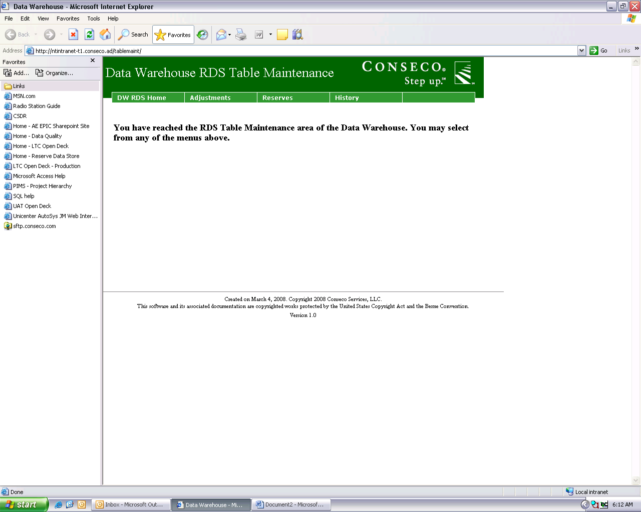

**Adjustments**

Main adjustments screen

The main adjustments screen contains 25 adjustments per page, and these adjustments can be sorted by Adjustment Key or by Adjustment Description by clicking on the green and underlined column headers.

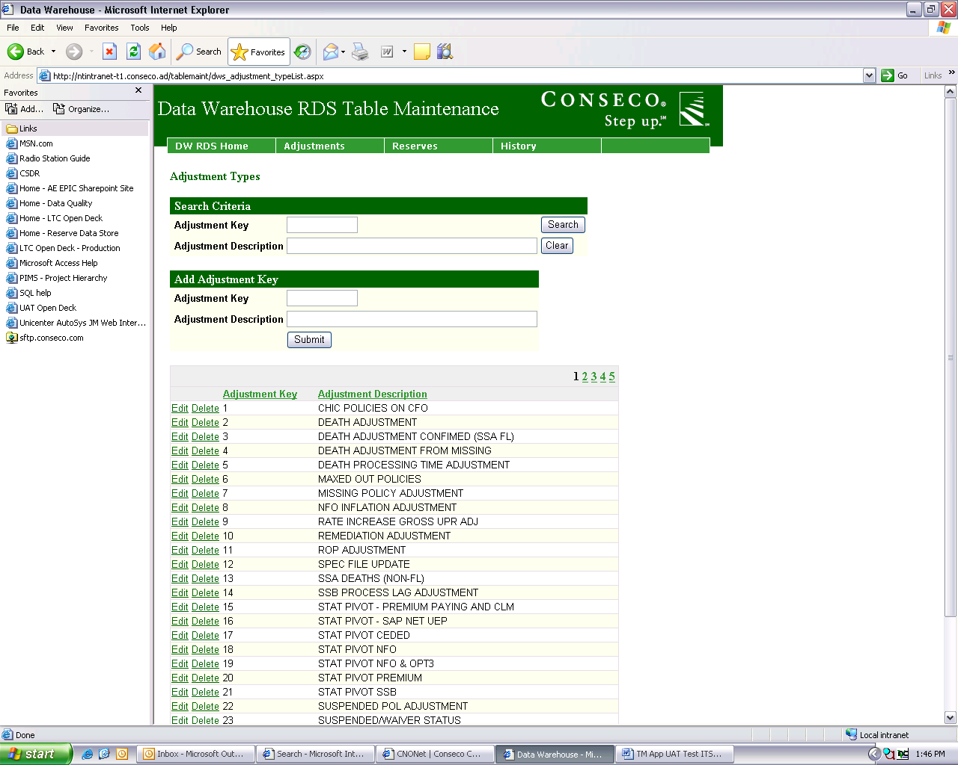

Searching For Adjustments

In this application the user has the ability to search for existing adjustment keys. The user can search by Adjustment Key only, Adjustment Description only (partial or full description), or a combination of the two.

Example results if searching by the Adjustment Key only:

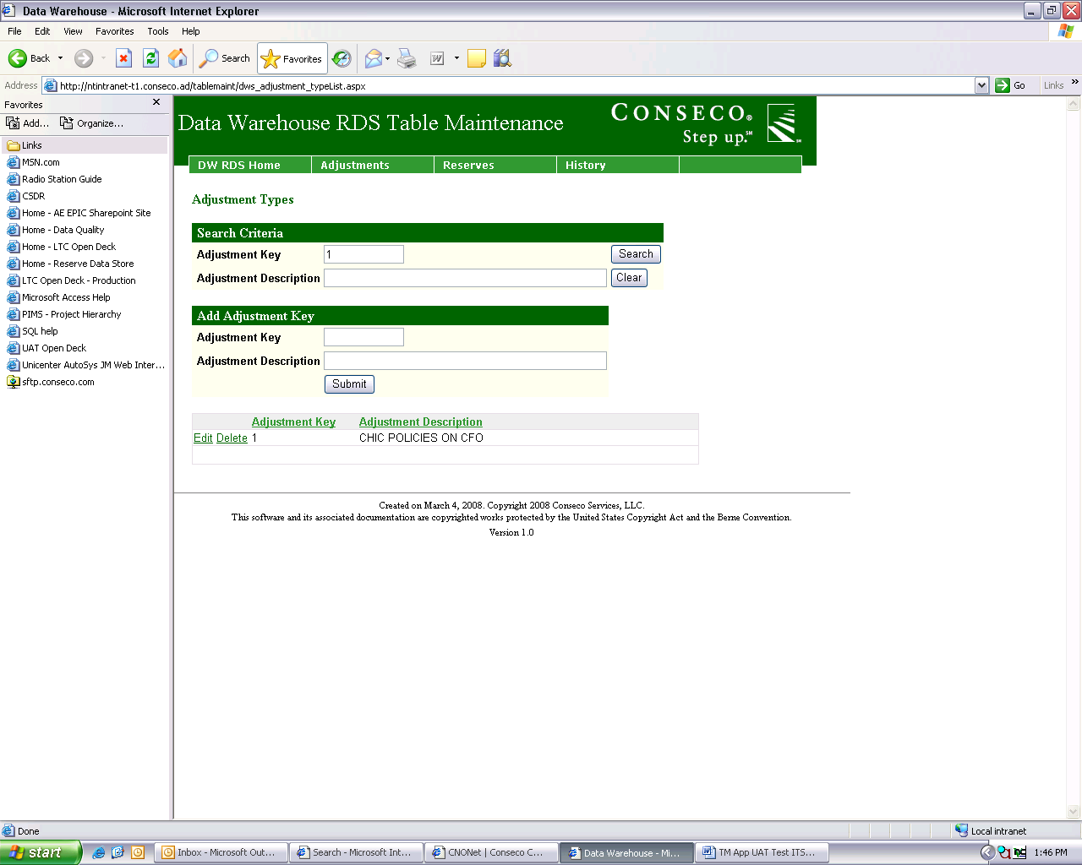

Example results if searching by the Adjustment Key and Adjustment Description:

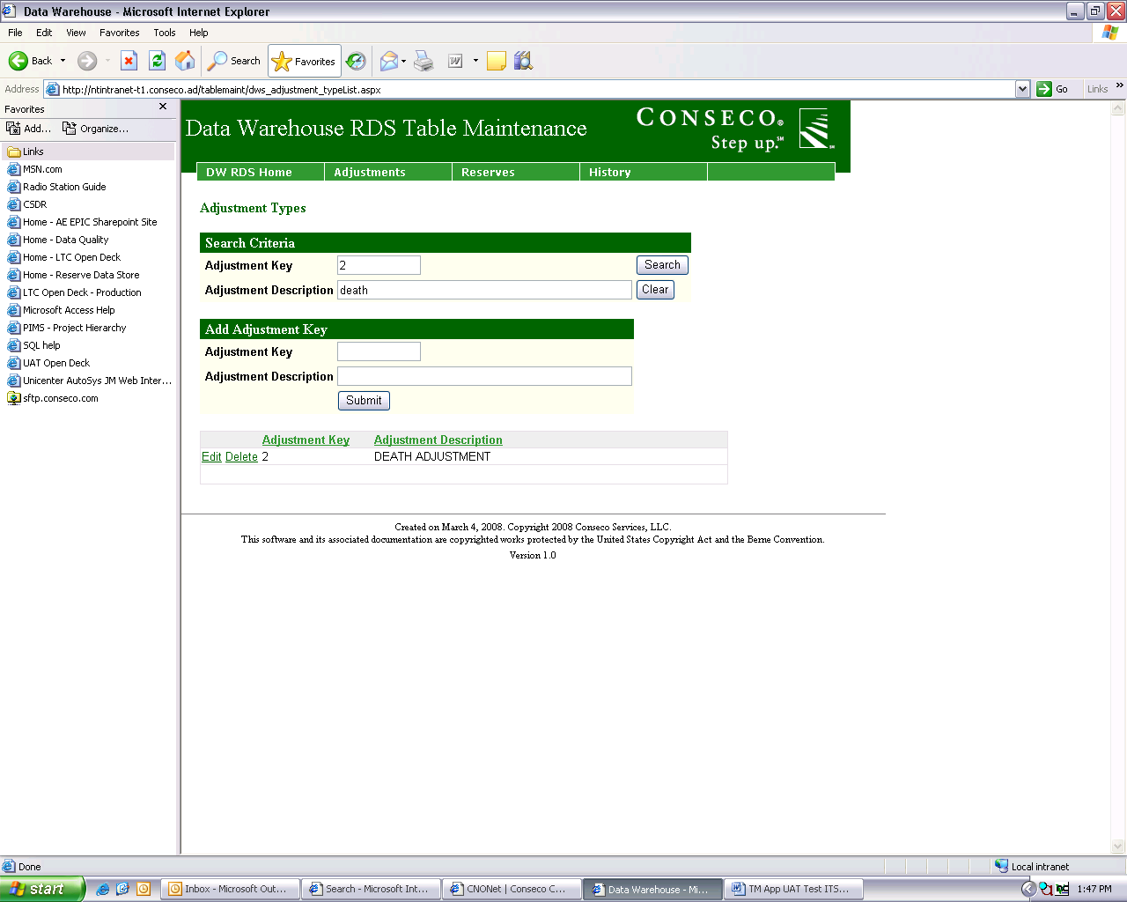

Example results if searching by Adjustment Description only:

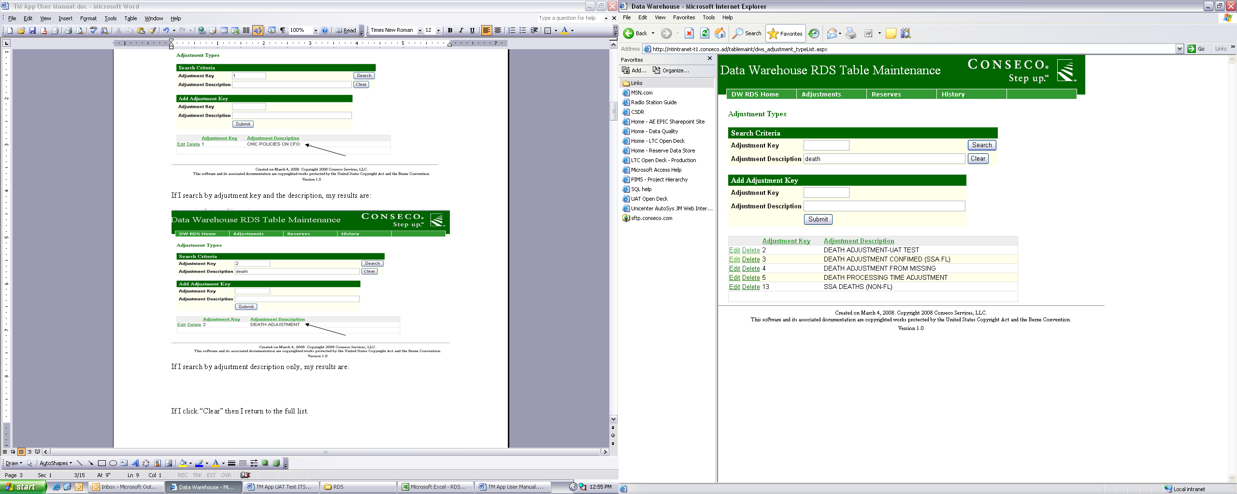

To return back to the whole list of Adjustments click “Clear.”

Editing Adjustments

Users are also able to edit existing Adjustment descriptions. In order to do this, click “Edit” next to the adjustment key that you wish to modify.

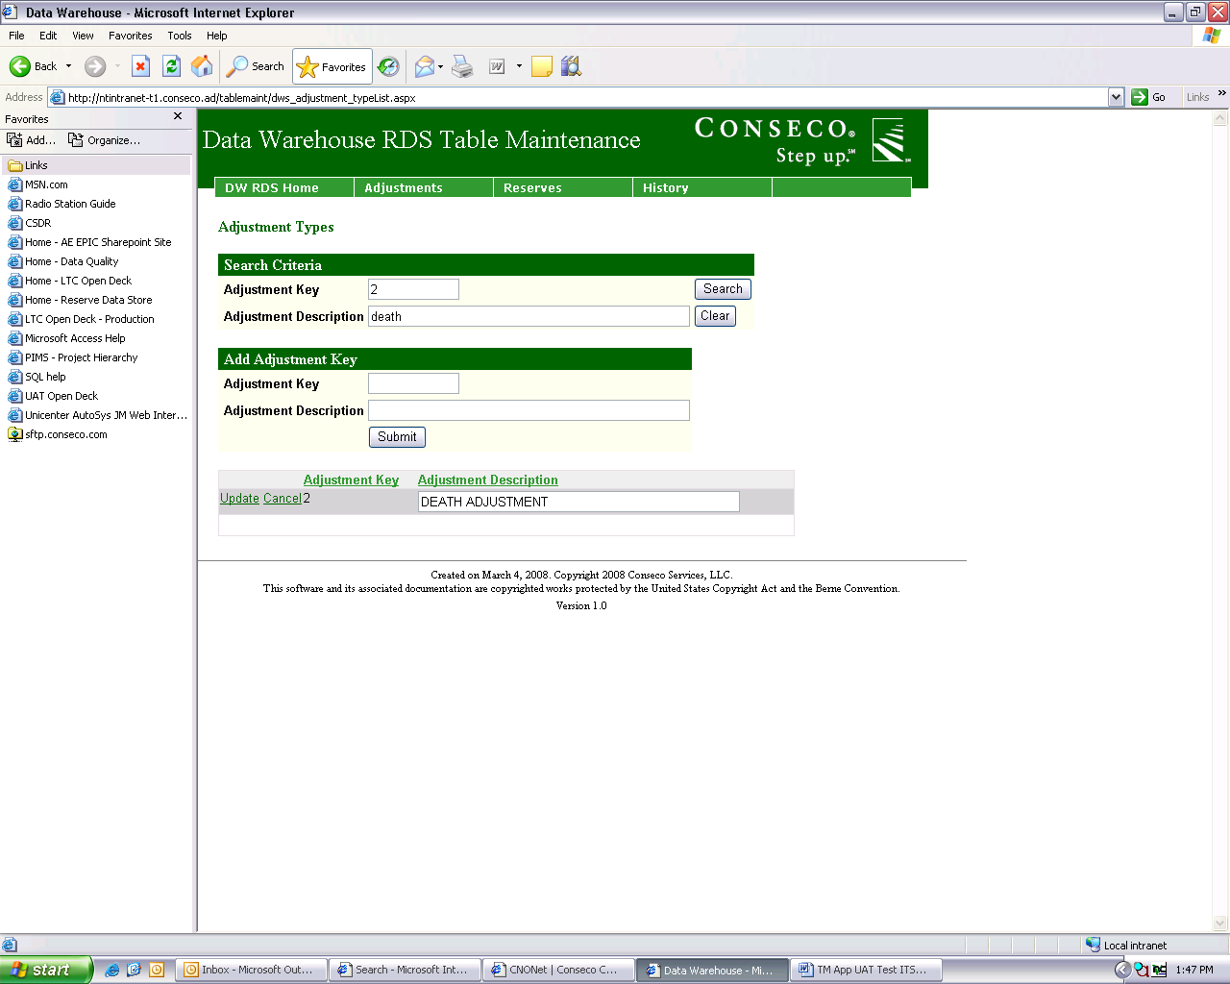

Make the desired changes to the description and then click “Update”…

If you decide not to edit the record, you can click cancel and the record will remain in the list unchanged. Notice in the screen shot below the description for Adjustment Key #2 now says, “DEATH ADJUSTMENT-UAT TEST.”

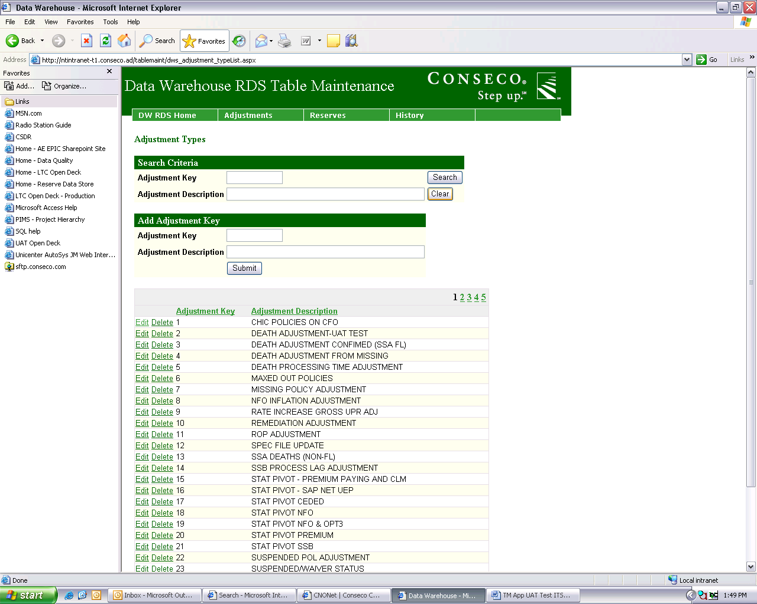

Deleting Adjustments

Users can delete adjustment keys and their descriptions. To delete an Adjustment Key and its description click “Delete” next to the adjustment you wish to get rid of. A warning message will appear after you click delete that asks you if you are sure that you want to delete the record.

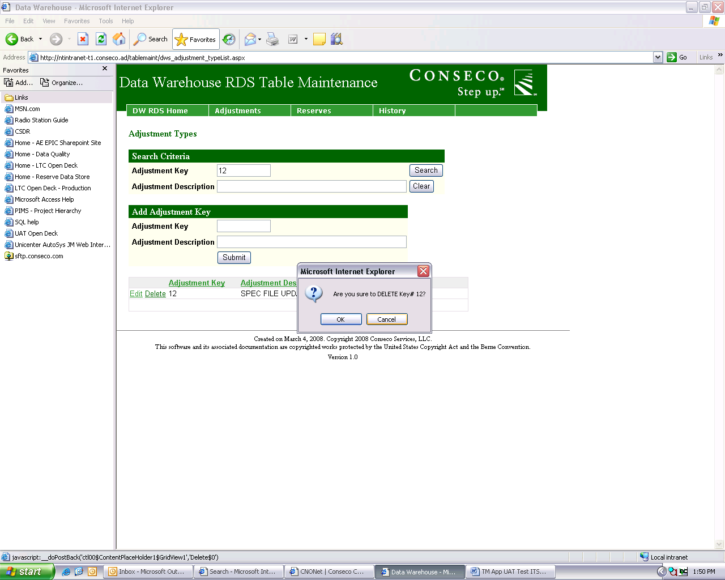

Click “Ok” If you really do want to get rid of the record. The adjustment will then be removed from the list of adjustments. Notice in the screen shot below that Adjustment Key 12 is no longer in the list.

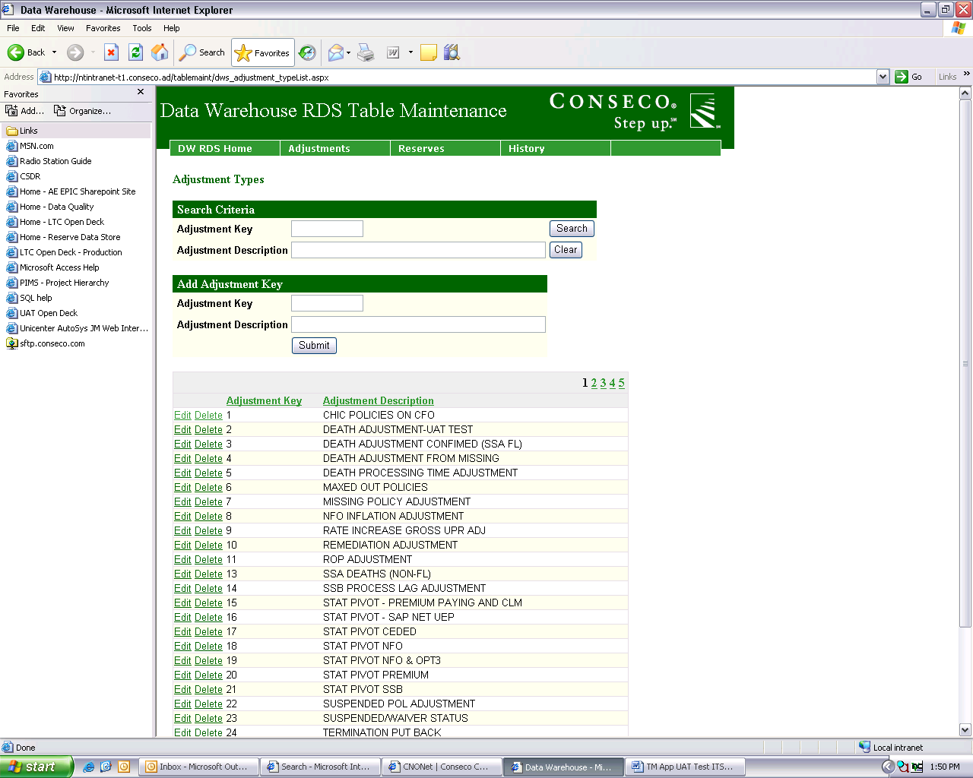

If you click “Delete” and do not want to get rid of the adjustment, then click “Cancel” and then record will not be deleted.

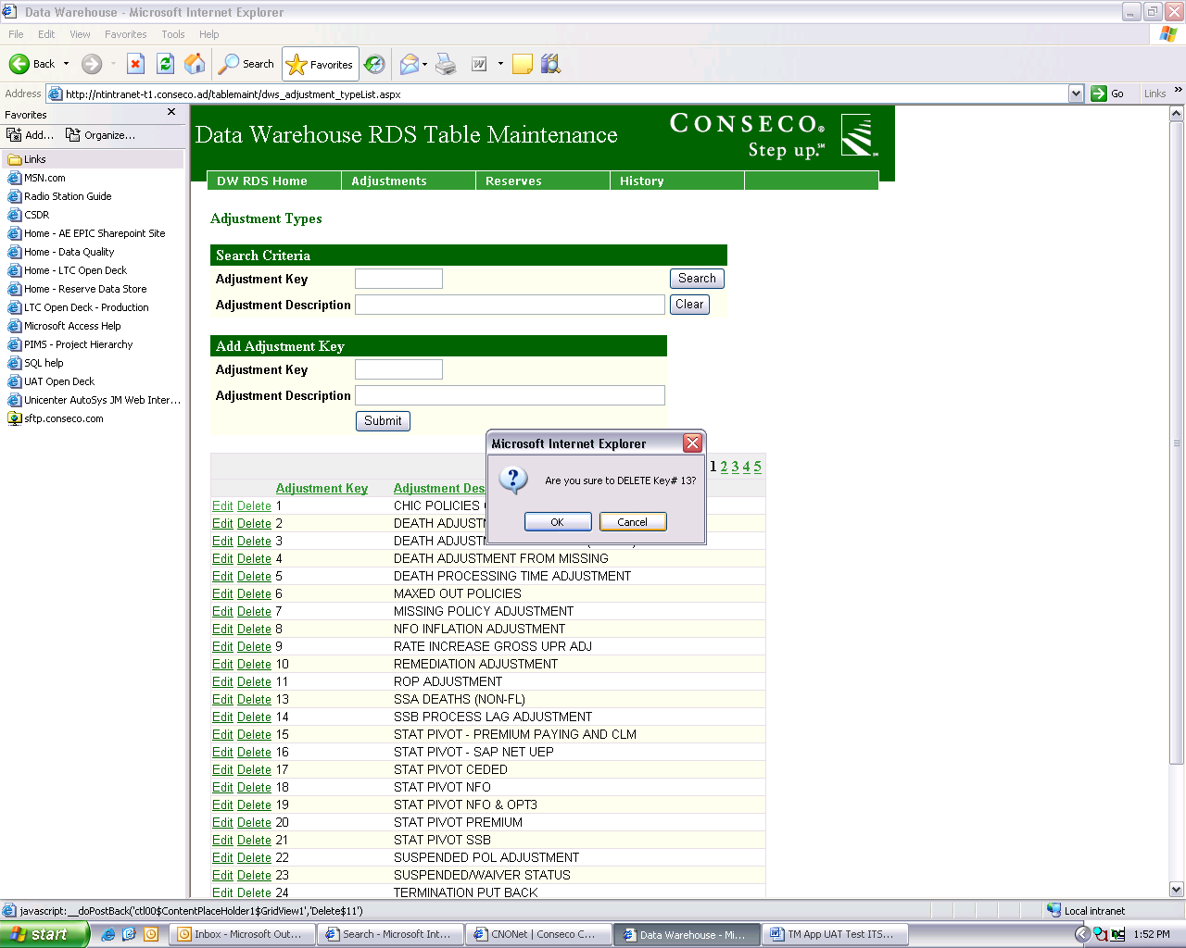

Adding Adjustments

Users can also add adjustments that do not already exist in the list. If you want to add adjustments, then in the “Add Adjustment Key” area type in the Adjustment Key and Description you wish to add and then click “Submit”.

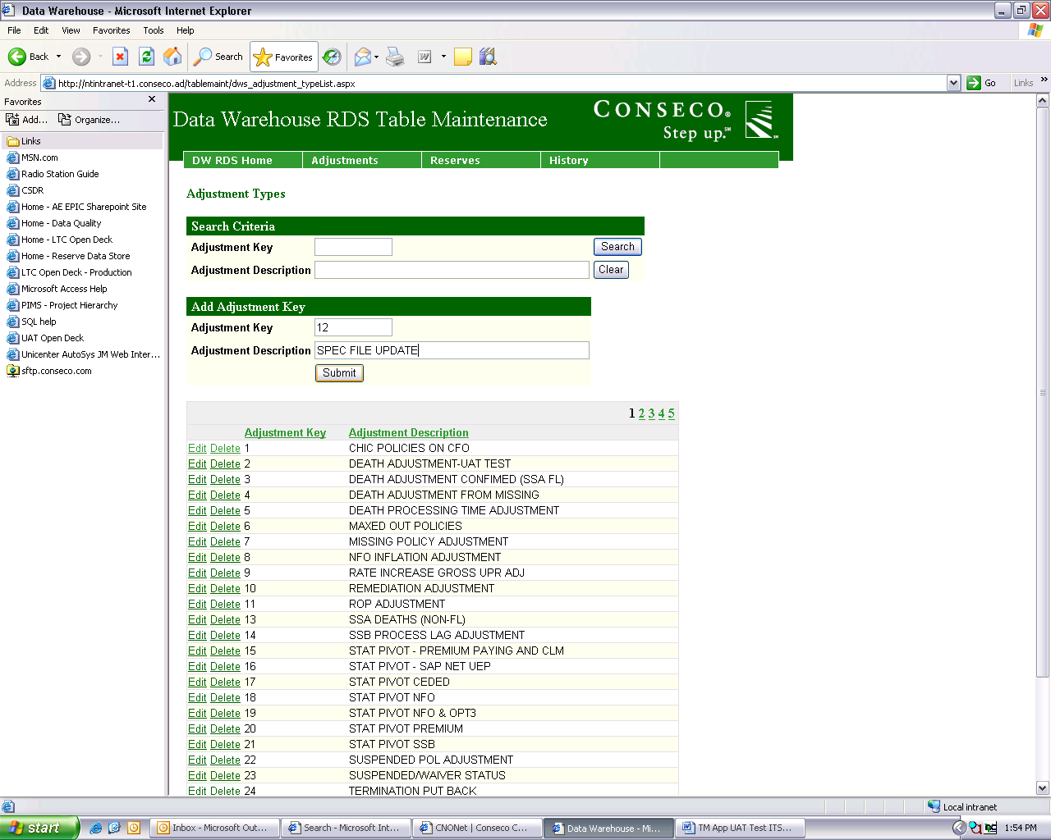

Notice that after you click “Submit”, the new adjustment becomes part of the list.

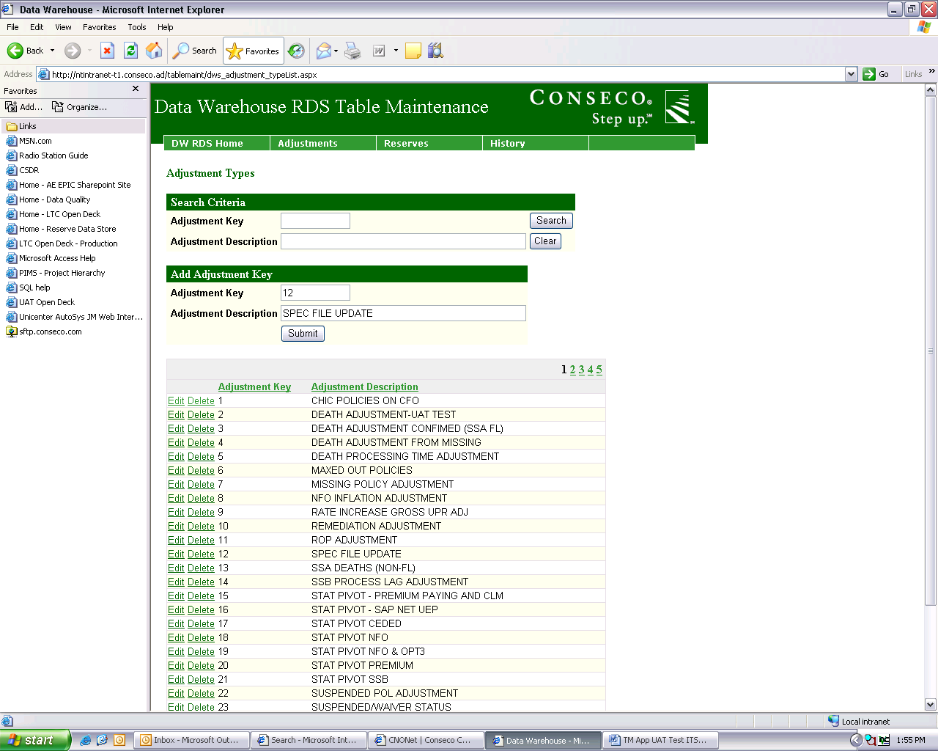

The data typed into the “Add Adjustment Key” section does not immediately go away; if you click submit again you will get the following message that tells you that the adjustment key already exists…

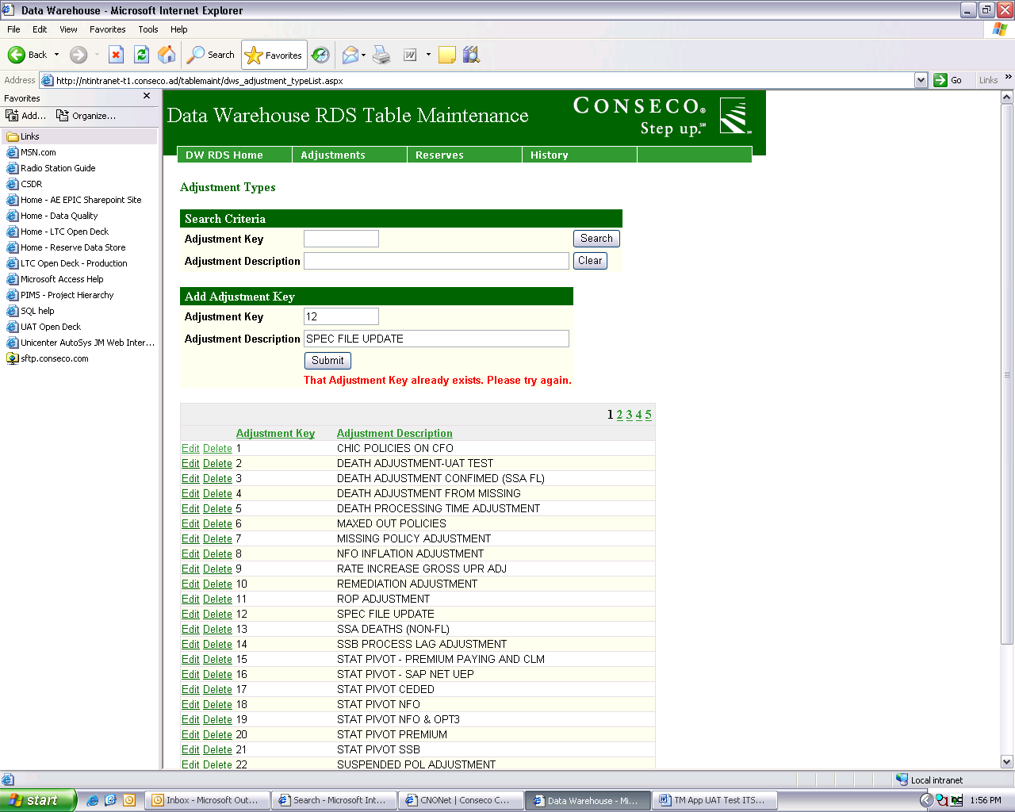

**Delete History**

On the delete history page there is a list of valuation dates that currently have data in the history tables.

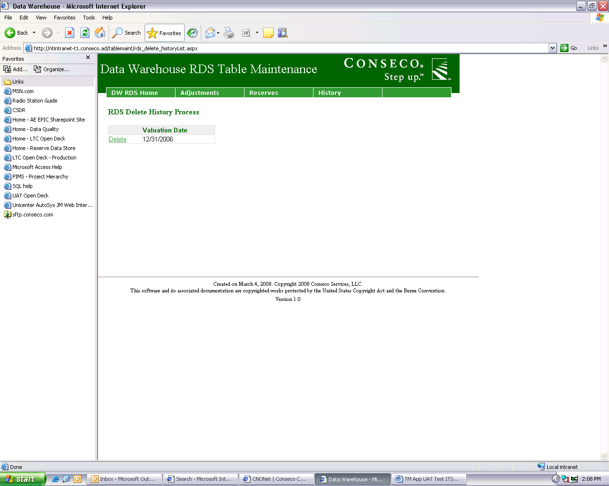

Click on “Delete” next to the date that you wish to delete all of its data from history…

You will receive a warning message asking you if you’re sure...

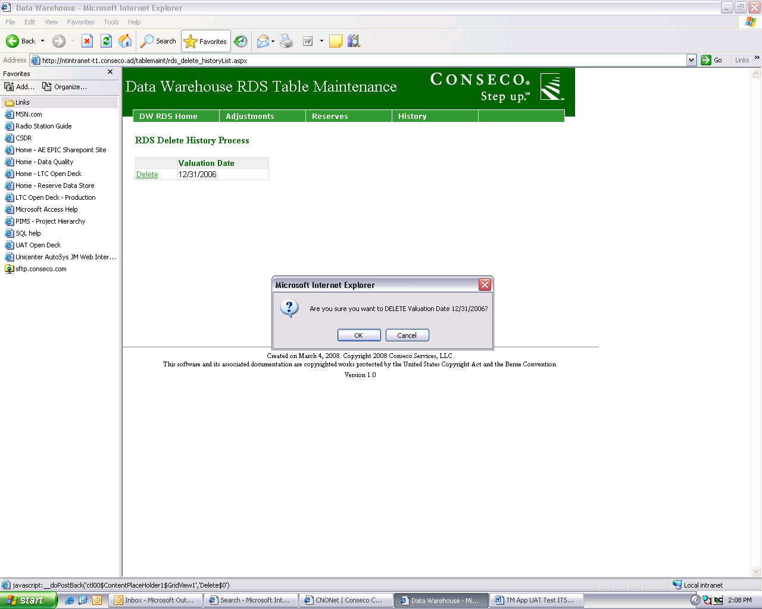

If you do want to continue to delete the history then click “Ok”, if you decide not to delete that date’s data from history, then click “Cancel”. The following screen is what you will see if you click “Ok”

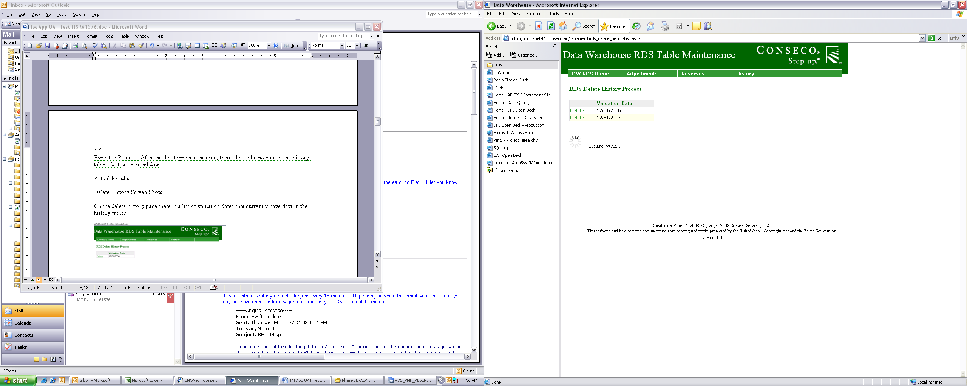Once the data has finished being deleted from history the following screen will be displayed.

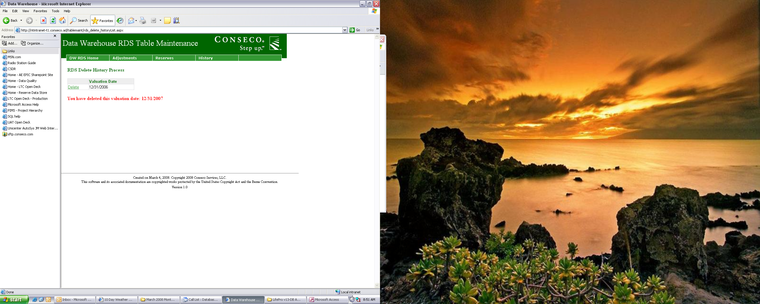

**Moving Data to History**

After the user has verified that the data in the view is correct they can click an “Approve” button to move the data to the history tables. When the user first goes to the “Approve for History” screen they will see the following:

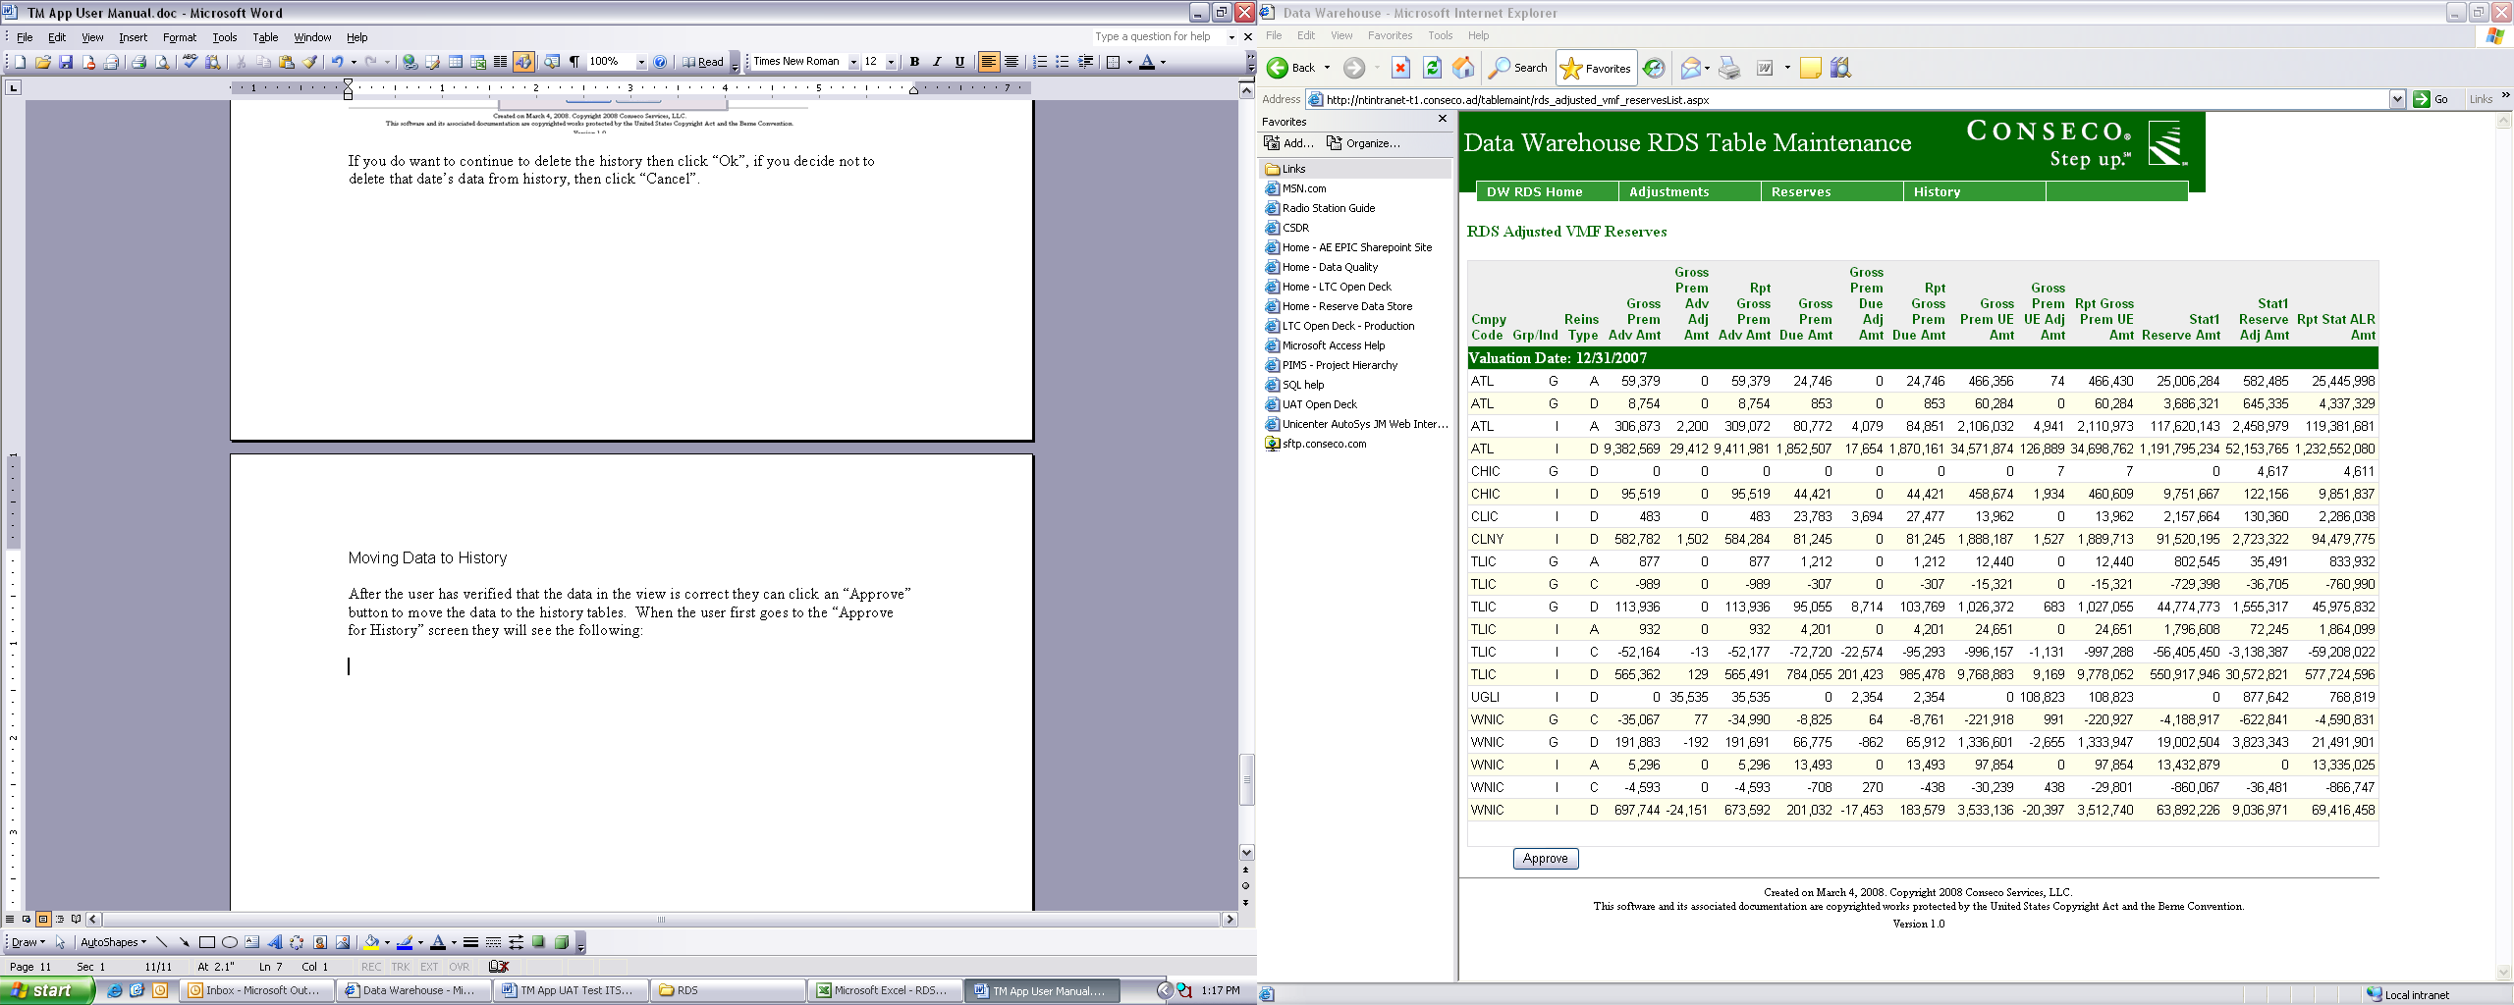

Once it has been verified that the data in the view is correct, you can click “Approve” and an e-mail will be sent to Plat to kick off the job that moves the data to history (LMMWHRD2.rds2_tm_load_history_tables.app). The following screen will be displayed:

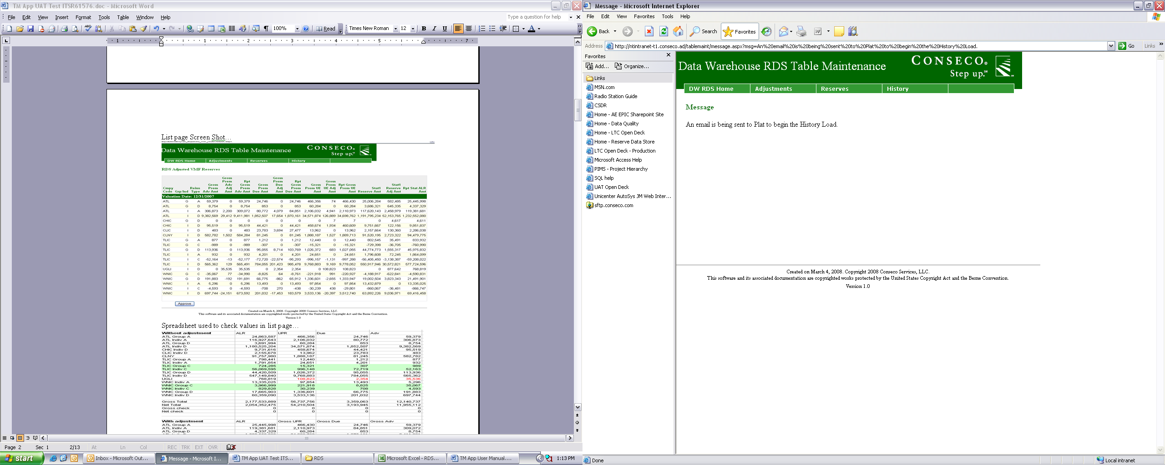

If the history tables already contain data for the valuation date that you are attempting to send to history, then you will receive the following error:

